Save the date - Geoconference, DLM Forum Meeting and E-ARK Meeting in Ljubljana from May 8th to 12th, 2023

With great pleasure, we’re announcing the Geoconference, the DLM Forum Meeting and the E-ARK Meeting in Ljubljana in May 2023.
The Geospatial Digital Records Preservation Conference, organized by the Archives of the Republic of Slovenia, Geoarh and the DLM Forum, will take place on Monday the 8th and Tuesday the 9th of May. An exciting 2-day hybrid event will bring together geospatial data producers, archives, data repositories, solution providers and their users. The theme of this year's conference is Sustainable access to Geospatial records in the Digital Economy. The Geoconference supports the aim of the Digital Europe Programme to make Europe greener and more digital, which inevitably puts geospatial records at the centre of the topic. Geospatial records covering longer periods of time will be invaluable in the effort to make better forecasts faster and accept informed decisions with greater clarity, and therefore support digital users.

The call for papers for the conference is open on the DLM Forums homepage, where you can find additional information about the conference topics as well as the extended abstract form for presentation proposals.

Following the conference, the DLM Forum Meeting will be held on Wednesday the 10th and Thursday the 11th of May, 2023 as well as an E-ARK Meeting on Friday the 12th of May.

Below you can find some practical information for conference participants; how to get to the venue, where to park your car, etc.

The venue
The conference, the DLM Forum Members’ Meeting and the E-ARK Meeting will take place in the Domus Medica Congress Center, the congress center of the Medical Chamber of Slovenia located on Dunajska cesta 162 in Ljubljana.

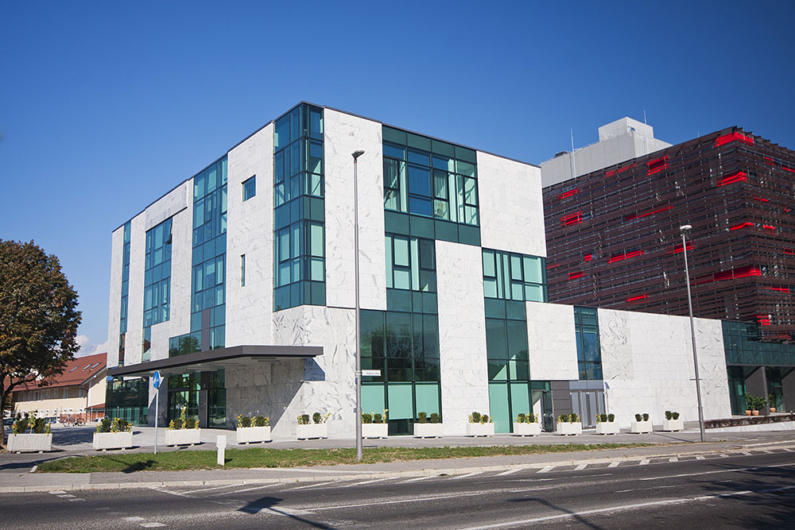

Getting to Ljubljana:
Ljubljana is located at the intersection of major European transportation routes, half way between Vienna and Venice. It is easily accessible by train, from the highway, and by air, with Ljubljana Jože Pučnik International Airport being only a short drive away (26 km).

Transfers to/from the airport
Shuttle transfers: GoOpti, Nomago, MNJ Shuttle, Markun Shuttle, ZUP prevozi.
Taxi: Taxi services are available in front of the airport building.
Rent-a-car: consult the list of rent-a-car service providers at the airport.
Regular bus route: a regular bus route connects the Ljubljana Jože Pučnik Airport and the Ljubljana Central Bus Station (bus stop no. 28).

The distances to the other airports:
- Airport Graz, Austria: 187 km
- Airport Klagenfurt, Austria: 85 km
- Airport Zagreb, Croatia: 140 km
- Airport Trieste, Italy: 130 km
- Airport Venice, Italy: 230 km

Several airports within reasonable distance to Ljubljana are served by low-fare carriers. Favourably priced scheduled transfers from these airports and Ljubljana can be booked through: GoOpti.com or Nomago shuttle service

Accommodations:
There are a number of hotels in the vicinity of the venue:
- Austria Trend Hotel Ljubljana, Dunajska cesta 154 (approximately 200 m from the venue) - @: reservations.ljubljana@austria-trend.at;
- Gloria Hotel, Dunajska 191 (approximately 300 m from the venue) – @: recepcija@gloria.si;
- Hotel Florjančkov hram, Dunajska cesta 238 (approximately 1100 m from the venue) - @: info@florjanckovhram.si;
- Holiday Inn Express Ljubljana, Podmilščakova ulica 51 (approximately 1800 m from the venue) - @: info@hiexljubljana.com.

Additional hotels can be found in the city center:
- B&B Hotel Ljubljana Park, Tabor 9 - @: ljubljana@hotelbb.com;
- City Hotel, Dalmatinova 15 - @: info@cityhotel.si;
- Hotel Center Ljubljana, Slovenska cesta 51 - @:info@hotelcenter.si;
- Urban Center Hotel, Štefanova ulica 4: sales@urbanhotel.si

Getting to the venue:
- if staying at the Austria Trend Hotel Ljubljana or Holiday Inn Express Ljubljana you can walk to the venue over the highway overpass;
- if staying in the Hotel Florjančkov hram or Gloria Hotel you can walk to the venue in the direction of the city center (right);
- if staying in the city center, you can reach the venue with bus lines: 6, 8, 11, 18 or 26 from the direction of the city center. You take the bus stop “Smelt” (next to the Austria Trend Hotel) and walk (approximately 200 m) over the highway overpass. You will need an Urbana value card. The cost of one ride is 1,30 EUR (including a 90-minute bus switching period). The Urbana value card can be purchased and topped up on Urbanomats or in newsstands.

Arriving by car:
The Domus Medica Congress Center has onsite parking (additional costs will apply) in the Dunajski kristali parking garage, Štukljeva cesta 46 in Ljubljana. The entrance is shown in the picture below. In the garage use the left parking space and follow the Domus Medica signs. The garage has direct access to the congress center.

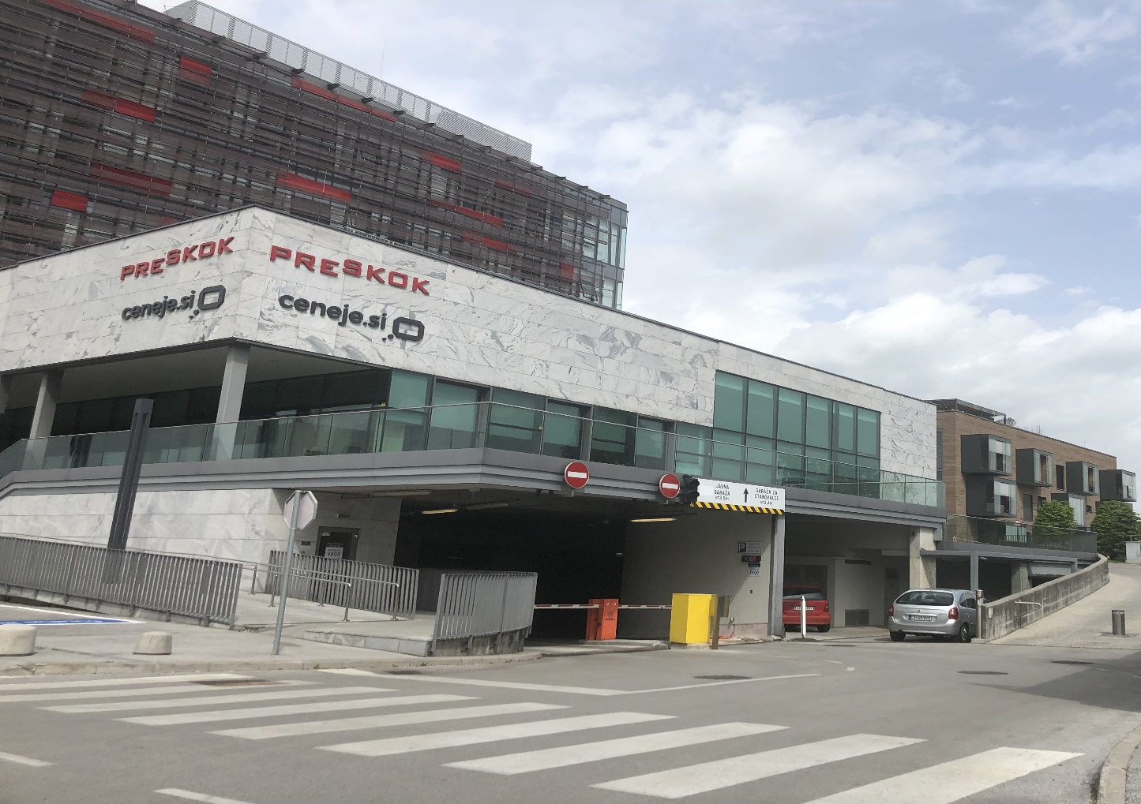

In close proximity of the congress center is the Smelt/World Trade Center parking house, Dunajska cesta 158 in Ljubljana (additional costs will apply). If you decide to park there, you will have to walk (proximately 200 m) over the highway overpass to the congress center.

We are looking forward to see you in Ljubljana!

